CSE 201 Project High Level Design Document

## Team Member Names

Brian Fotheringham

Mike Zhao

Nick Kane

Zhouwei Gu

## Team Project Title

King 17

Project Description

Web based application to connect students of a specific college or university to other students and student groups. Users will create a personal or group account, add themselves to a college or university, and become a part of that college or university’s network. Users can follow other users and student groups, like posts made by other users and student group, and post pictures or statements themselves. Users can also create groups for themselves and other users apart from public student groups.

## Overall Design Description

Object Oriented Design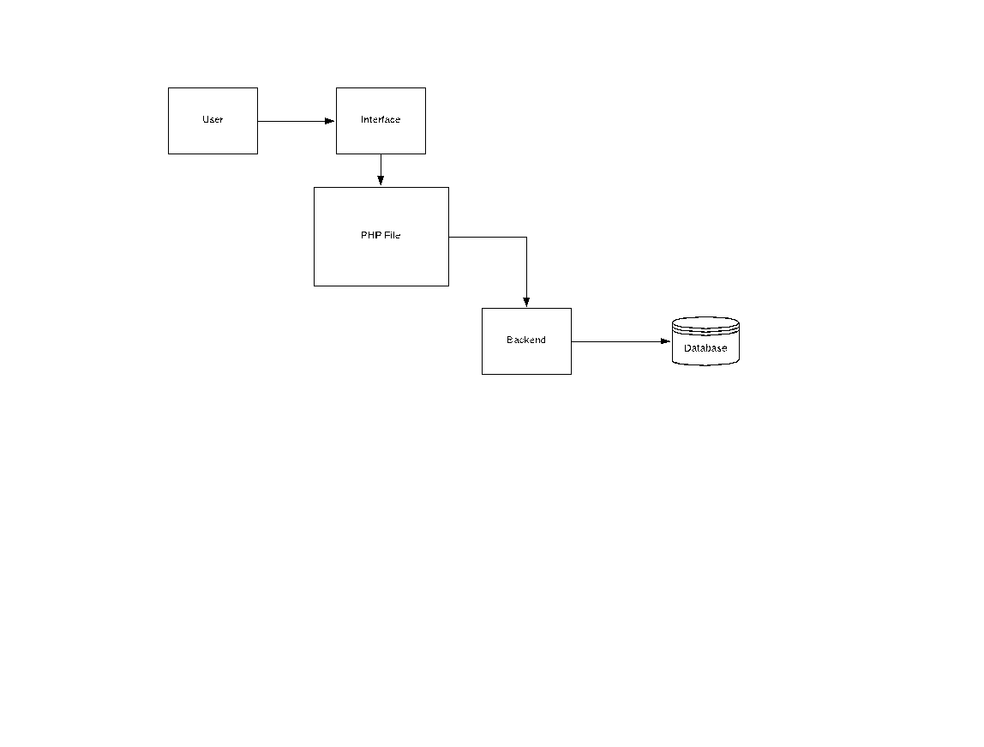

## UML Diagram 1

Use case diagram showing all user options while using the web application.

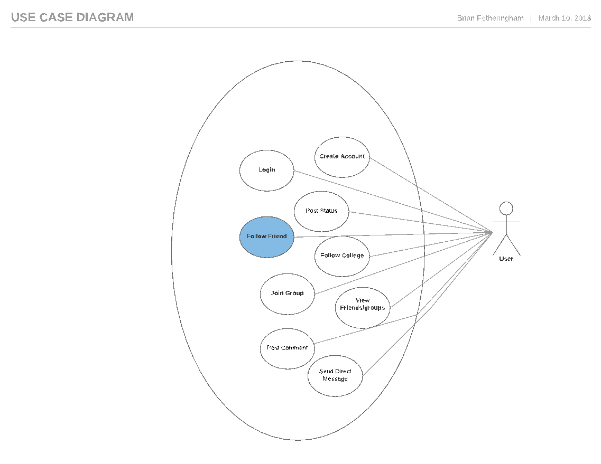

## UML Diagram 2

Three use case diagrams showing the user’s options on each page of the application.

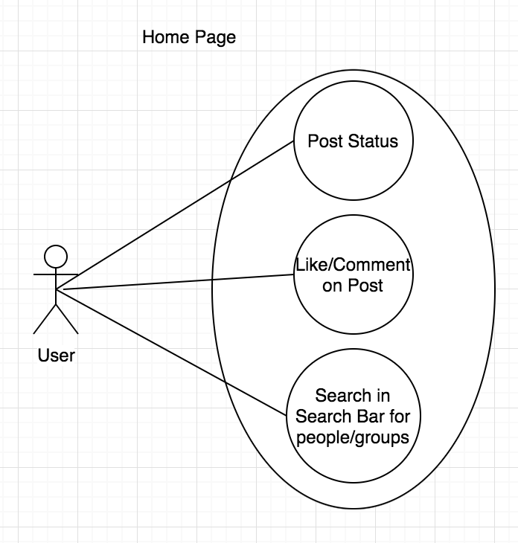

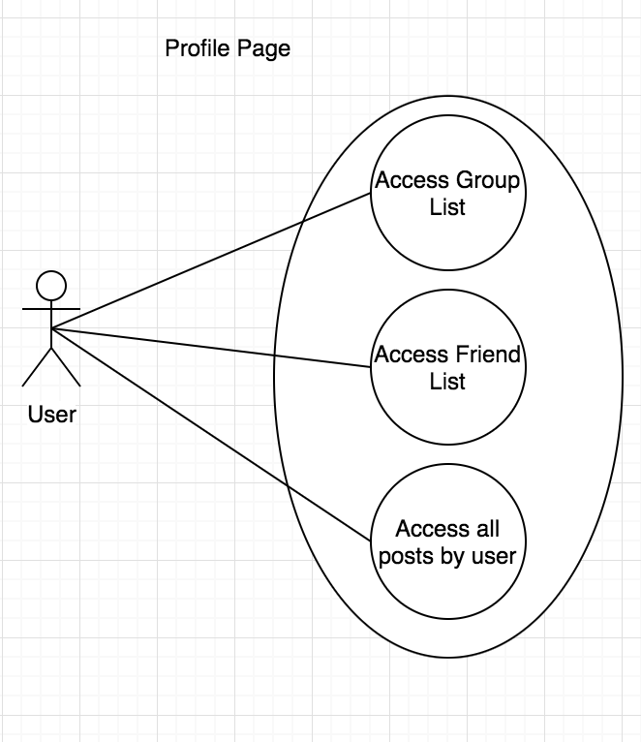

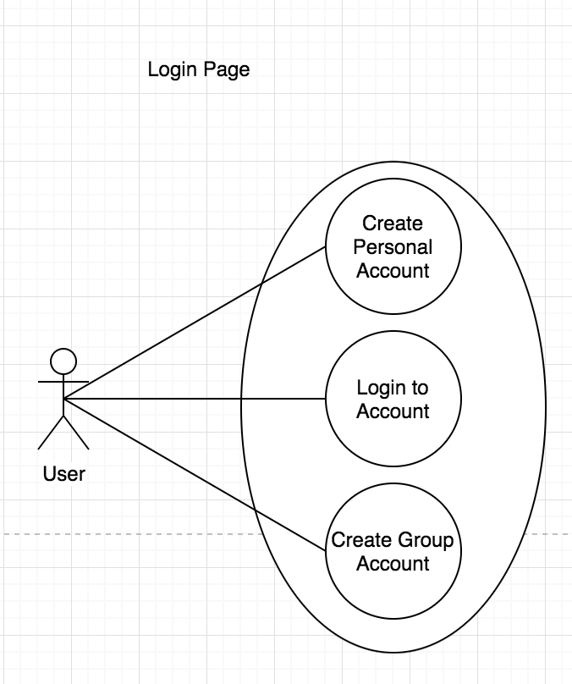

## UML Diagram 3

Case Diagram showing the different classes being used in the php backend of the web application.

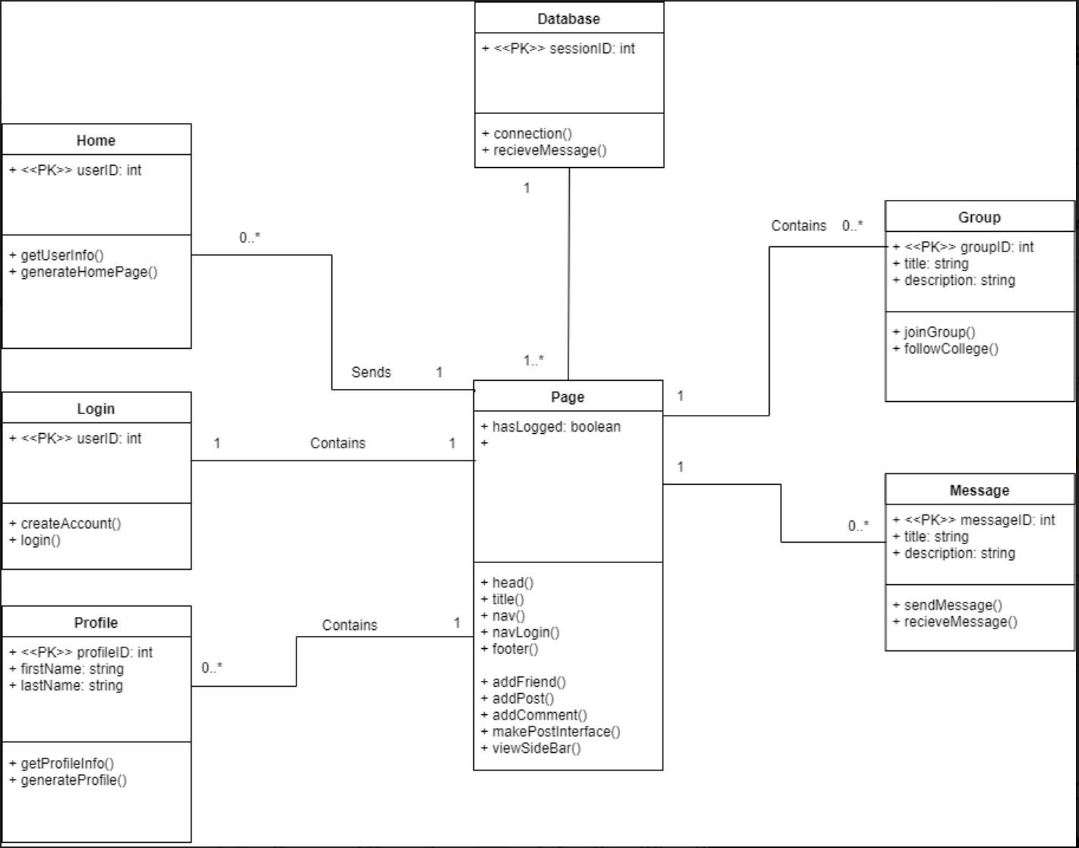

## UML Diagram 4

This Sequence Diagram Shows the sequence of creating an account on the web application

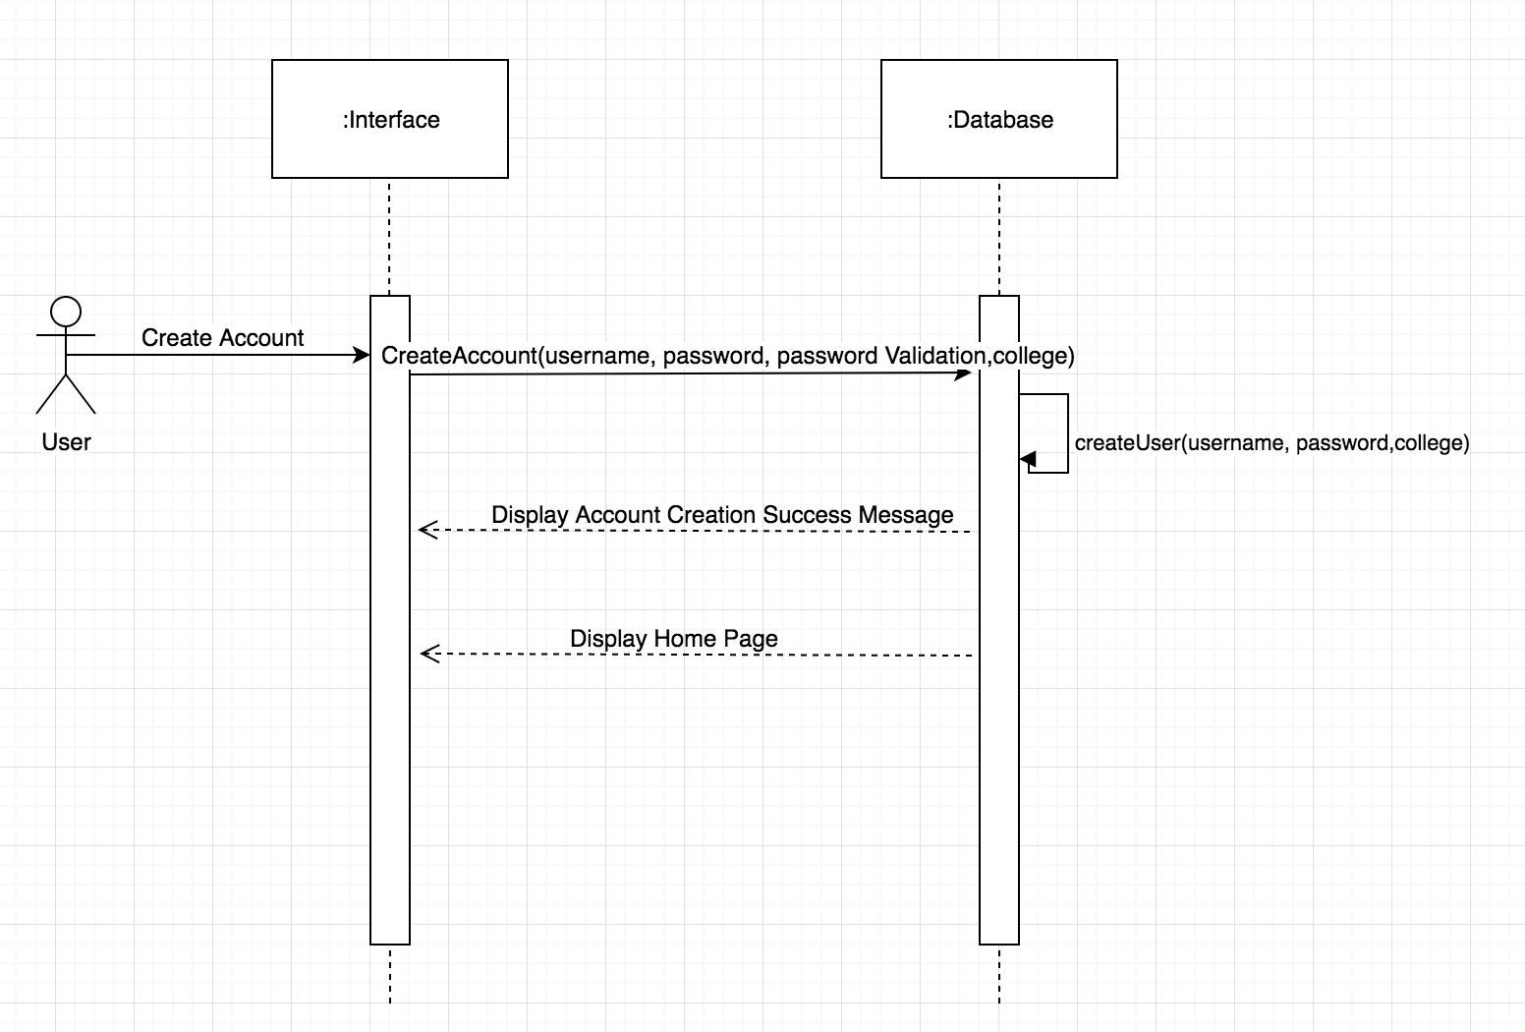

## UML Diagram 5

This Sequence Diagram Shows the sequence of logging in to your account on the web application

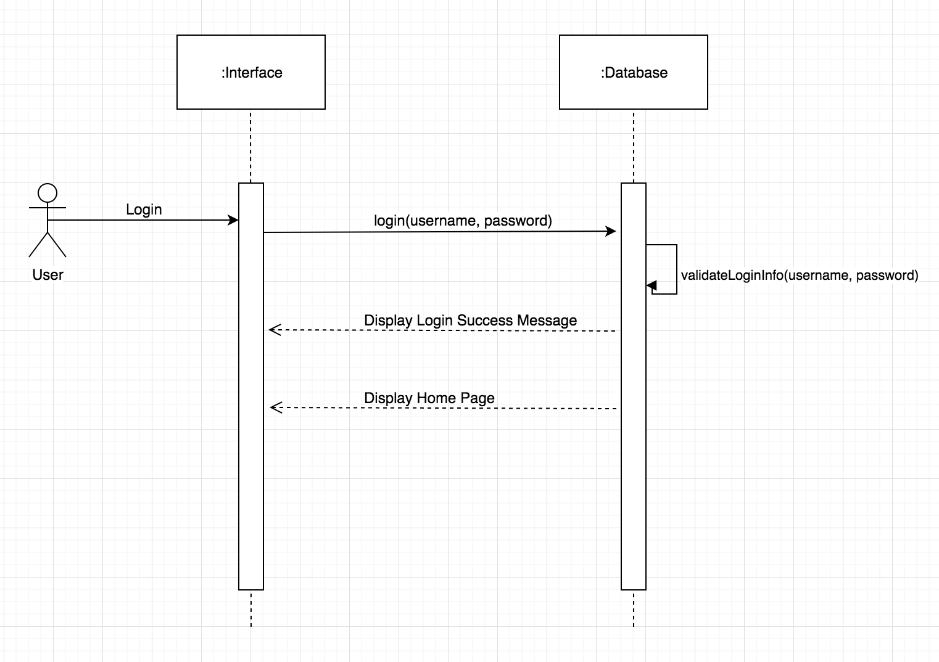

## UML Diagram 5

This Sequence Diagram Shows the sequence of creating a post on your home page.

